Purchase Number
Order Number
Report Number
Fume Cupboard through Examination and Test Report as Required by COSHH Regulations
Copies of the completed report should be held by the examiner, the employer, and the Science Department and retained for at least five years.
Establishment
Report Number
Fume cupboard ID
Location
Model
Year
House usage
Examiner  Dawn Moorhead  S4NI  Info@s4ni.com | Airflow meter  S/N 0263148 | Outdoor wind conditions

Have you seen the commissioning report and/or initial test data? | ☐YES  ☐NO
Have you seen the user manual? | ☐YES  ☐NO
Have you seen the LOGBOOK? | ☐YES  ☐NO

Comments

Labels should be attached to all fume cupboards with the last test date, name of the examiner, and Pass, Fail, or Not Satisfactory notification. Failed units must not be used. Not satisfactory units can be used with provisos (conditions of use), which must be written down.
Examiner’s Signature
Date
Previous Test Date
Next Test Date
Stage 1: Notes of Visual Inspection
Inspection check | Results
Work surface and linings
Is there any damage?
If it is made of asbestos cement, has it been reported, particularly noting if dusty or flaking?
Fail if it could produce significant dust levels in the room. Otherwise, consult the employer. Sealing it may be possible.
Glazing
Is it dirty? Are there any cracks or other damage?
Is it plastic or glass? (If glass, report if there is no evidence that it is safety glass: e.g., no engraving on the glass or no statement from the supplier of the fume cupboard. (Explosions in fume cupboards are very rare, so the presence of ordinary glass is not a reason for failure unless the employer stipulates it. It is possible to cover glass with safety film.)
Baffle
Is it dirty? Is there any damage?
Very old fume cupboards may not have a baffle. This is no reason for failing the fume cupboard.
Sash mechanism
Does it function satisfactorily? Are there signs of damage to the cables?
Fail only if the sash is likely to descend rapidly, i.e., one side is broken.
Take steps to repair it before further deterioration.
Sash slits
Are there stops to:
(a) Limit the aperture to the correct maximum height?
(b) prevent it from being closed completely?
While stops should be fitted, labels indicating sash limits are temporarily acceptable. Take steps to fit stops.
Do not fail unless the employer stipulates it; fix labels.
Electricity, gas, water, and drainage services
Is there any corrosion or damage that makes the services unsafe?
Check the drip cup, trap (does it contain water?), and drain for signs of leaks, blockage, etc., and the pipes and wires under the fume cupboard.
Fail only if there is a real possibility of a gas leak, of electric shock, or a spark from an electric circuit igniting the gas.
Fan
Is the direction of flow correct?
Is there any sound of excessive vibration? (Tests on the performance of the fan are in the next section.)
Fail if the direction of the air flow is incorrect.
Ducting (where visible)
Are there any signs of damage, particularly to seals?
Are there any reports of smells along its route?
Fail if there is a significant leak at a point where the pressure inside the duct is above atmospheric.
Internal light working?

Stage 2: Notes of Technical Performance Measurements
Feature | Comments
Measure air Velocities  At a sash height of 400 mm | - Insert your results in the grid below.  - Look at the table of recorded readings and repeat any reading that seems to be very different from the general pattern.  - If any measurement is less than 0.3 m/s, the tube cupboard has failed to open to a depth of 400 mm (but it may be worth checking the accuracy of the anemometer speed).  - If it fails at 400 mm, lower the sash height to 300 mm and repeat the readings. If the fume cupboard passes, the fume cupboard must not be used for carrying out chemical reactions, but it could be used for dispensing chemicals.  - If the fume cupboard fails at even 300 mm, it must not be used under any circumstances and should be so marked.  - Make sure the safe working height for the sash is clearly marked on the fume cupboard.  - Add up the 3 measurements and divide the answer by 3 to obtain the average face velocity.  - Average face velocity at 400 mm:  (0.39 + 0.41 + 0.41) / 3 =……. m/s⁻¹  - You will need the max and min face velocities to test for variation.  Maximum face velocity:….. m/s⁻¹ Minimum face velocity:…. m/s⁻¹  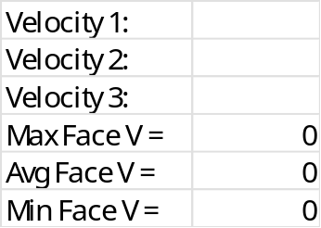
Check the bypass system by lowering the sash to 200 mm | - Insert your results in the grid below  - Add up the 3 measurements and divide the answer by 3 to obtain the average face velocity.  - Average face velocity at 200 mm …… ms⁻¹  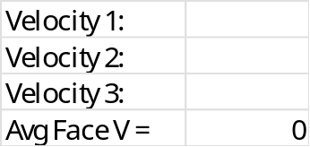
Check any low velocity alarms (if fitted)
Check the fume cupboard noise level. | - With the door closed, measure face velocity for faster airflow at 200 mm, sound meter readings at a height of 1.5 m, and 1.5 m in front of the face is…… dB when OFF and …… dB when ON.
Compare the present result with past results | - Are there any notable changes from previous results?
Diagnose the causes of any problem. | (Suggest calling in specialist engineers if necessary, e.g., CLEAPSS guidance leaflet PS04)
Check the upper and lower variations in the face velocity | Use the equation below to obtain the upper variation as a percentage  Upper variation =  $$\frac{\left(\text{maximum face velocity} − \text{average face velocity}\right)}{\text{average face velocity}}×100$$  - Upper variation: …..%  Use the equation below to obtain the lower variation as a percentage  Lower variation (%) =  $$\frac{\left(\text{average face velocity} − \text{minimum face velocity}\right)}{\text{average face velocity}}×100$$  - Lower variation: …..%  - Make a report if the upper or lower variation is greater than 30% or if greater than 20% with more than one variation on the same side of the cupboard.  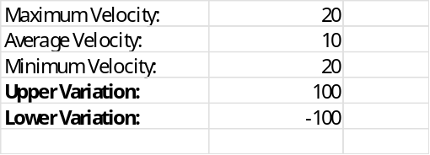
Observations of employees using the fume cupboard | Comments

Stage 3: Notes on Control Effectiveness Tests
A filter efficiency test (See section 9.1) | Polychloroethene  (tetrachloroethene or trichloroethene) test for testing the seating of the filter | Mass of flask, bung and contents before = m₁ = ___ g
A filter efficiency test (See section 9.1) |  | Mass of flask, bung and contents after = m₂ = ___ g
A filter efficiency test (See section 9.1) |  | Time on stop clock = ___ seconds
A filter efficiency test (See section 9.1) |  | Reading on detection tube = ___ ppm
A filter efficiency test (See section 9.1) |  | Rate of release of polychlorothene vapour  $$R=\frac{\left(m_{1} − m_{2}\right)}{t}×f {\text{cm}}^{3}{\text{s}}^{-1}$$  Where:  - $f=145$for tetrachloroethene  - $f=183$for trichloroethene  $$R=$$  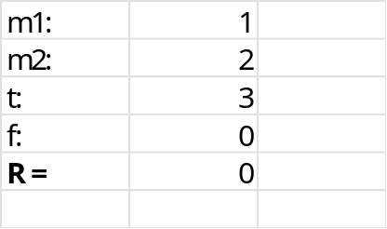
A filter efficiency test (See section 9.1) |  | Is the measured concentration of polychloroethene (tetrachloroethene/trichloroethene) vapour greater than the value in Table 9.1 for the measured release rate?  If yes, check the seating; if the seating is OK, a new filter is required.
A filter efficiency test (See section 9.1) | Sulfur dioxide test for testing the saturation of the filter by acid gases  (could also be used for testing the seating of the filter) | Mass of basin, sulfur, and gauze before = m₁ = ……. g
A filter efficiency test (See section 9.1) |  | Mass of basin, sulfur, and gauze after = m₂ = …….. g
A filter efficiency test (See section 9.1) |  | Time on stop clock = ………seconds
A filter efficiency test (See section 9.1) |  | Reading on detection tube = …… ppm
A filter efficiency test (See section 9.1) |  | Rate of release of sulfur dioxide gas =  $$R=\frac{\left(m_{1} − m_{2}\right)}{t}×751{\text{cm}}^{3}{\text{s}}^{-1}$$=  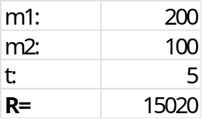
A filter efficiency test (See section 9.1) |  | Is the measured concentration of sulfur dioxide gas greater than the value in Table 9.2 for the measured release rate?  If yes, a new filter is required.

